SDLC (Software Development Life Cycle)
1. Requirement Gathering Phase
Requirement Document (BRD / SRS)
This document contains all business and functional requirements provided by the client.
Activities
- Understand customer requirements
- Define project scope
- Identify business objectives
- Gather functional and non-functional requirements
Roles Involved
- Product Owner (PO)
- Business Analyst (BA)
- Solution Architect
Deliverables
- Business Requirement Document (BRD)
- Software Requirement Specification (SRS)
- User Stories
- Wireframes

2. Wireframe Design
Definition
A wireframe is a visual blueprint of the application showing page layouts, navigation flow, and user interactions.
Purpose
- Understand application structure
- Improve user experience
- Validate requirements before development
Tools Used
- Figma
- Adobe XD
- Balsamiq
Roles Involved
- Product Owner
- UI/UX Designer
- Architect
3. Technical Design Phase
Technical Document
A detailed design document prepared by the Technical Lead and reviewed by the Architect.
Includes
Classes
Blueprints used to create objects in Object-Oriented Programming.
Interfaces
Define methods that must be implemented by classes.
Components
Reusable software modules used in the application.
Cloud Architecture
Infrastructure design for deployment.
Technology Stack
- Frontend
- Backend
- Database
- Cloud Platform
- APIs
Roles Involved
- Technical Lead
- Software Architect
- Senior Developers
Deliverables
- High Level Design (HLD)
- Low Level Design (LLD)
- Architecture Diagrams

4. Coding Phase
Definition
Developers implement the application based on technical design documents.
Activities
- Writing source code
- Implementing business logic
- Database integration
- API development
Roles Involved
- Software Developers
- Technical Lead
Output
- Source Code
- Unit Test Cases

5. QA (Quality Assurance) Phase
Definition
Testing team validates the application and identifies defects.
Activities
- Execute test cases
- Verify requirements
- Raise bugs
- Retest fixes
Roles Involved
- QA Engineers
- Test Lead
Output
- Bug Reports
- Test Reports

Environments in SDLC
1. Development Environment (DEV)
Purpose
Used by developers to write and test code.
Features
- Frequent code changes
- Developer access
- Initial testing

2. Testing Environment (TEST)
Purpose
Used by QA team for functional testing.
Features
- Stable builds
- Test case execution
- Defect identification

3. UAT Environment (User Acceptance Testing)
Purpose
Used by business users or clients to validate requirements.
Features
- Final validation
- User feedback
- Approval for release

4. Integration Environment (INT)
Purpose
Used to test integration between multiple systems.
Features
- API testing
- Service communication validation
- End-to-end testing

5. Pre-Production Environment (PPE)
Purpose
Replica of production environment used before deployment.
Features
- Final verification
- Performance validation
- Release readiness check
6. Production Environment (PROD)
Purpose
Live environment used by actual users.
Features
- Real customer traffic
- Business operations
- Continuous monitoring
GO LIVE
The process of deploying the application from PPE to Production for end users.
Types of Testing
1. Unit Testing
Testing individual functions or modules.
Example:
Testing a login function separately.

2. Integration Testing
Testing interaction between multiple modules.
Example:
Login module communicating with database.

3. System Testing
Testing the complete application as a whole.
Example:
Testing entire e-commerce website.

4. Black Box Testing
Testing functionality without knowing internal code.
Focus:
- Inputs
- Outputs
- Business requirements

5. API Testing
Testing APIs for request and response validation.
Checks:
- Status Codes
- Response Time
- Data Accuracy

6. Automation Testing
Using tools/scripts to execute test cases automatically.
Tools:
- Selenium
- Cypress
- Playwright
Benefits:
- Faster execution
- Repeatability

7. Regression Testing
Ensures new changes do not affect existing functionality.
Performed after:
- Bug fixes
- New feature implementation

8. Load Testing
Measures system performance under expected user load.
Example:
1000 users accessing simultaneously.

9. Stress Testing
Tests system beyond normal capacity limits.
Purpose:
- Identify breaking point
- Evaluate recovery capability

Maintenance Phase
Definition
Final phase of SDLC where the application is monitored and supported after deployment.
Activities
- Bug fixing
- Performance optimization
- Security updates
- Feature enhancements
Types of Maintenance
- Corrective Maintenance – Fix defects.
- Adaptive Maintenance – Support environment changes.
- Perfective Maintenance – Improve performance.
- Preventive Maintenance – Prevent future issues.

Short Definitions
What is SDLC?
SDLC is a structured process used to design, develop, test, deploy, and maintain software applications.
What is UAT?
User Acceptance Testing is the final testing phase where business users validate the application before production deployment.
Difference between DEV and PROD?
- DEV: Used for development and testing.
- PROD: Live environment used by customers.
What is Regression Testing?
Testing existing functionalities after code changes to ensure no new defects are introduced.
What is Go-Live?
The process of releasing an application to the production environment for end users.
What is PPE Environment?
A pre-production environment that closely resembles production and is used for final validation before deployment.
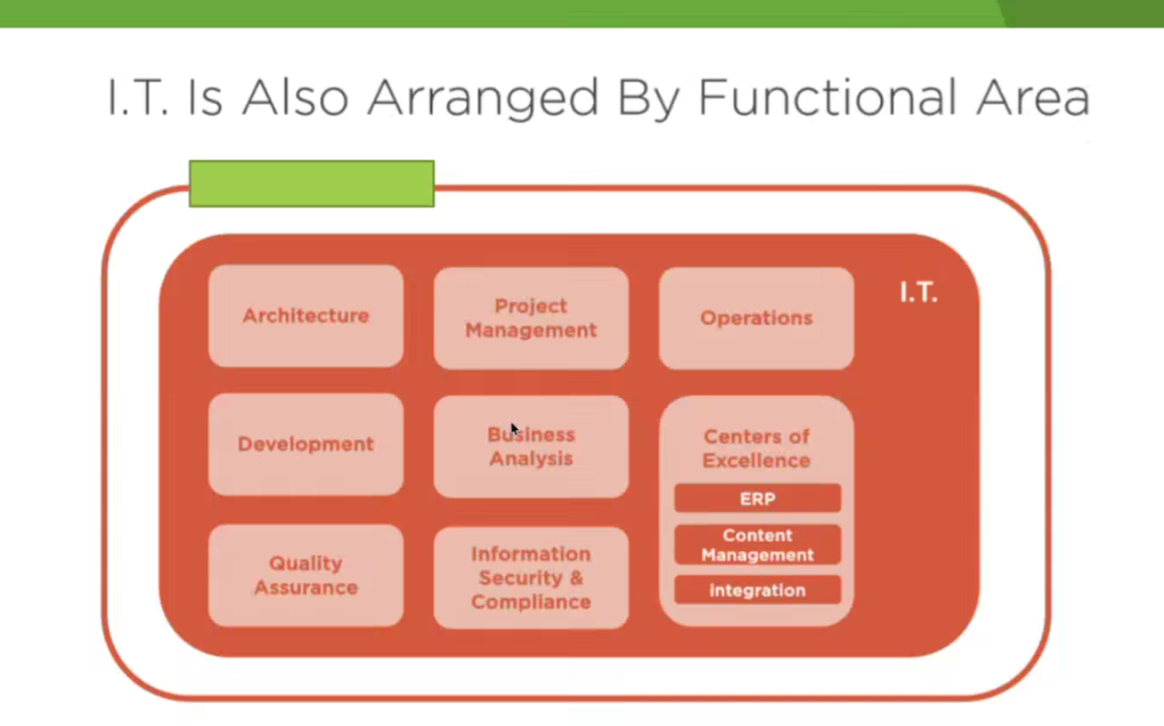
IT Functional Areas – Notes
Introduction
Information Technology (IT) departments in organizations are divided into different functional areas. Each area has specific responsibilities and works together to deliver technology solutions that support business operations.
The major IT functional areas shown in the diagram are:
- Architecture
- Project Management
- Operations
- Development
- Business Analysis
- Centers of Excellence
- Quality Assurance
- Information Security & Compliance

1. Architecture
Definition
Architecture is responsible for designing the overall structure and technology framework of applications and systems.
Responsibilities
- Define system architecture
- Select technology stack
- Design cloud infrastructure
- Ensure scalability and performance
Roles
- Solution Architect
- Enterprise Architect
- Technical Architect
Interview Answer
Architecture defines how software components, databases, networks, and cloud services work together to meet business requirements.

2. Project Management
Definition
Project Management ensures projects are completed on time, within budget, and according to requirements.
Responsibilities
- Project planning
- Resource allocation
- Risk management
- Team coordination
- Progress tracking
Roles
- Project Manager
- Scrum Master
- Delivery Manager
Interview Answer
Project Management focuses on planning, monitoring, and successfully delivering projects.

3. Operations
Definition
Operations manages and supports IT systems after deployment.
Responsibilities
- System monitoring
- Incident management
- Backup and recovery
- Server maintenance
- Performance monitoring
Roles
- System Administrator
- Operations Engineer
- Support Engineer
Interview Answer
Operations ensures applications and infrastructure run smoothly in production.

4. Development
Definition
Development is responsible for building software applications.
Responsibilities
- Coding
- API development
- Database integration
- Bug fixing
- Feature implementation
Roles
- Software Developer
- Full Stack Developer
- Backend Developer
- Frontend Developer
Interview Answer
Development transforms business requirements into working software solutions.

5. Business Analysis
Definition
Business Analysis acts as a bridge between business stakeholders and technical teams.
Responsibilities
- Gather requirements
- Create user stories
- Analyze business processes
- Prepare requirement documents
Roles
- Business Analyst
- Product Owner
Interview Answer
Business Analysis converts business needs into clear technical requirements.

6. Quality Assurance (QA)
Definition
QA ensures software quality by identifying and preventing defects.
Responsibilities
- Functional testing
- Regression testing
- Automation testing
- Bug reporting
Roles
- QA Engineer
- Test Engineer
- Automation Tester
Interview Answer
Quality Assurance verifies that software meets requirements and works correctly before release.

7. Information Security & Compliance
Definition
This team protects organizational data and ensures compliance with regulations.
Responsibilities
- Security monitoring
- Risk assessment
- Compliance audits
- Vulnerability management
- Access control
Roles
- Security Analyst
- Cybersecurity Engineer
- Compliance Officer
Interview Answer
Information Security protects systems, applications, and data from cyber threats.

8. Centers of Excellence (CoE)
Definition
A Center of Excellence is a specialized team that provides expertise, standards, and best practices for specific technologies.
Responsibilities
- Technology governance
- Standards development
- Knowledge sharing
- Process improvement
Examples
ERP (Enterprise Resource Planning)
Integrates business processes such as finance, HR, inventory, and procurement into a single system.
Examples: SAP, Oracle ERP

Content Management
Manages creation, storage, and publishing of digital content.
Examples: SharePoint, WordPress

Integration
Connects multiple applications and systems to exchange data seamlessly.
Examples: REST APIs, MuleSoft, Apache Kafka

Relationship Between Functional Areas
Business Analysis
↓
Architecture
↓
Development
↓
Quality Assurance
↓
Operations
↓
Maintenance
Project Management oversees all phases, while Security & Compliance ensures governance and protection throughout the project lifecycle.

Interview Quick Questions
What are the major functional areas of IT?
Architecture, Project Management, Development, Business Analysis, Quality Assurance, Operations, Information Security, and Centers of Excellence.
What is the role of a Business Analyst?
A Business Analyst gathers requirements and acts as a bridge between business users and technical teams.
What is a Center of Excellence?
A specialized team that provides expertise, standards, and best practices for specific technologies or business functions.
What is the difference between Development and Operations?
- Development builds software.
- Operations manages and supports software after deployment.
Why is Quality Assurance important?
QA ensures software quality, reliability, and customer satisfaction by identifying defects before production deployment.

DevOps and Agile – Documentation Notes

1. What is DevOps?
Definition
DevOps is a software development approach that combines Development (Dev) and Operations (Ops) teams to improve collaboration, automate processes, and deliver software faster and more reliably.
Objectives of DevOps
- Faster software delivery
- Improved collaboration
- Continuous Integration and Deployment (CI/CD)
- Better software quality
- Reduced deployment failures
DevOps Lifecycle
Plan
↓
Develop
↓
Build
↓
Test
↓
Release
↓
Deploy
↓
Operate
↓
Monitor
Common DevOps Tools
- Git & GitHub
- Jenkins
- Docker
- Kubernetes
- Ansible
- Azure DevOps
- AWS
Interview Answer
DevOps is a culture and set of practices that combines development and operations teams to automate software delivery and improve collaboration.

2. Advantages of DevOps
Faster Software Delivery
Automates build, test, and deployment processes.
Improved Collaboration
Developers and operations teams work together efficiently.
Better Quality
Continuous testing helps identify defects early.
Increased Reliability
Automation reduces human errors.
Faster Problem Resolution
Monitoring tools help detect and fix issues quickly.
Customer Satisfaction
Frequent releases provide faster delivery of features.
Continuous Improvement
Regular feedback helps improve products and processes.

3. What is Agile Methodology?
Definition
Agile is a software development methodology that focuses on iterative development, customer collaboration, and continuous delivery of software.
Agile Principles
- Customer satisfaction
- Continuous delivery
- Flexibility to change
- Team collaboration
- Continuous improvement
Features of Agile
- Small development cycles
- Frequent releases
- Faster feedback
- Improved quality
Agile Process
Requirements
↓
Sprint Planning
↓
Development
↓
Testing
↓
Review
↓
Release
Interview Answer
Agile is an iterative software development methodology that delivers software in small increments and adapts quickly to changing requirements.

4. What is Scrum?
Definition
Scrum is a framework within Agile used to manage and execute software projects through short iterations called sprints.
Scrum Roles
Product Owner (PO)
- Defines requirements
- Maintains product backlog
- Prioritizes work
Scrum Master
- Facilitates Scrum activities
- Removes obstacles
- Ensures Agile practices are followed
Development Team
- Develops and tests the application
Scrum Artifacts
Product Backlog
List of all project requirements.
Sprint Backlog
Tasks selected for the current sprint.
Increment
Working software delivered at the end of the sprint.
Sprint
A Sprint is a fixed time period (usually 2–4 weeks) in which a set of tasks is completed.
Interview Answer
Scrum is an Agile framework that organizes work into short development cycles called sprints to deliver software incrementally.

5. Important Meetings in Agile
Sprint Planning Meeting
Purpose
Plan work for the upcoming sprint.
Participants
- Product Owner
- Scrum Master
- Development Team
Output
Sprint Backlog

Daily Scrum (Stand-Up Meeting)
Purpose
Track daily progress and identify blockers.
Duration
15 Minutes
Questions Discussed
- What did I complete yesterday?
- What will I do today?
- Are there any blockers?

Sprint Review Meeting
Purpose
Demonstrate completed work to stakeholders.
Activities
- Product demonstration
- Feedback collection
- Requirement validation

Sprint Retrospective Meeting
Purpose
Identify improvements for future sprints.
Discussion Points
- What went well?
- What can be improved?
- Action items for next sprint

Agile Meeting Flow
Sprint Planning
↓
Daily Scrum
↓
Sprint Review
↓
Sprint Retrospective

6. Advantages of Agile
Faster Delivery
Software is delivered in small increments.
Better Quality
Continuous testing improves quality.
Flexibility
Changes can be incorporated easily.
Reduced Risk
Problems are identified early.
Improved Customer Satisfaction
Continuous customer involvement.
Better Team Collaboration
Encourages communication and teamwork.
Continuous Improvement
Retrospectives help improve performance.

Quick Interview Answers
What is DevOps?
DevOps combines development and operations teams to automate software delivery and improve collaboration.
What is Agile?
Agile is an iterative software development methodology focused on delivering software in small increments and adapting to changes.
What is Scrum?
Scrum is an Agile framework that manages work using short development cycles called sprints.
What is a Sprint?
A Sprint is a fixed-duration iteration (usually 2–4 weeks) used to complete a set of tasks.
What are the important Agile meetings?
- Sprint Planning
- Daily Scrum
- Sprint Review
- Sprint Retrospective
What are the advantages of Agile?
- Faster delivery
- Better quality
- Flexibility
- Reduced risk
- Customer satisfaction
- Continuous improvement
Difference Between Agile and DevOps
Agile | DevOps
Focuses on development process | Focuses on development and operations
Uses Scrum/Kanban | Uses CI/CD and automation
Delivers software incrementally | Delivers software continuously
Improves team collaboration | Improves collaboration and deployment speed

